Consider the following table summarizing the details of a project:

|  |  |  |  |  |
| --- | --- | --- | --- | --- |
| Activity | Predecessor(s) | Duration (weeks) | | |
|  |  | o | m | p |
| A | - | 5 | 6 | 7 |
| B | - | 1 | 3 | 5 |
| C | - | 1 | 4 | 7 |
| D | A | 1 | 2 | 3 |
| E | B | 1 | 2 | 9 |
| F | C | 1 | 5 | 9 |
| G | C | 2 | 2 | 8 |
| H | E,F | 4 | 4 | 10 |
| I | D | 2 | 5 | 8 |
| J | H,G | 2 | 2 | 8 |

1. Construct the project network (Hint: use activity on arrow, AOA).
2. Find the expected duration and variance of each activity.
3. Find the critical path and expected project completion time (Hints: consider earliest start time for forward pass and latest completion time for backward pass).
4. What is the probability of completing the project on or before 22 weeks (use Z table, std. normal distribution table)?

 Node

Earliest start time

Latest completion time

Activity (time)

a)

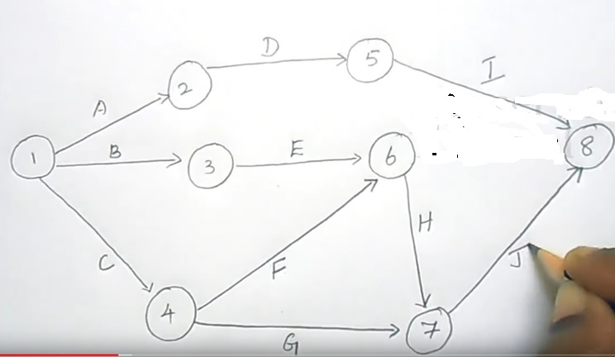

b)

|  |  |  |  |  |  |  |
| --- | --- | --- | --- | --- | --- | --- |
| Activity | Predecessor(s) | Duration (weeks) | | | Mean / Expected  Duration | Variance |
| o | m | p |
| A | - | 5 | 6 | 7 | 6 | [(7-5)/6]2=0.111 |
| B | - | 1 | 3 | 5 | 3 | 0.444444444 |
| C | - | 1 | 4 | 7 | 4 | 1 |
| D | A | 1 | 2 | 3 | 2 | 0.111111111 |
| E | B | 1 | 2 | 9 | 3 | 1.777777778 |
| F | C | 1 | 5 | 9 | 5 | 1.777777778 |
| G | C | 2 | 2 | 8 | 3 | 1 |
| H | E,F | 4 | 4 | 10 | 5 | 1 |
| I | D | 2 | 5 | 8 | 5 | 1 |
| J | H,G | 2 | 2 | 8 | 3 | 1 |

Mean te= expected duration

te= (to+4*tm+tp)/6

Variance σ2=[(tp- to)/6]2

c)

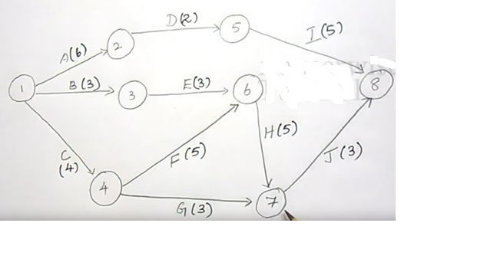

**For Critical path**

Earliest start time – Forward pass

Latest completion time – Backward pass

Earliest start time:

**Forward Pass**

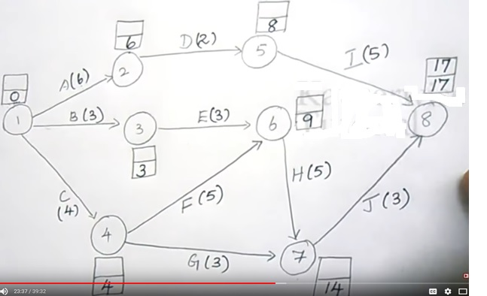

Latest completion time:



**Backward Pass**

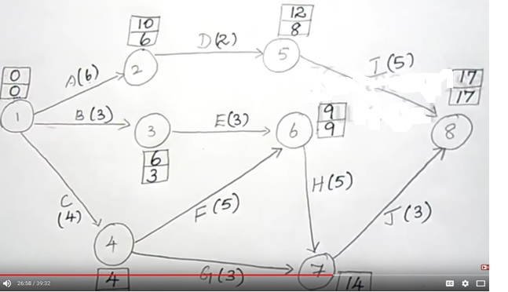

Critical Path:

Critical path is the longest path in the network

**For node**

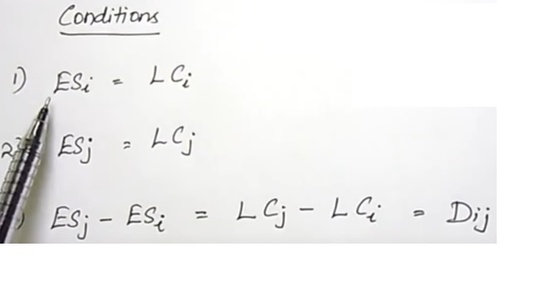

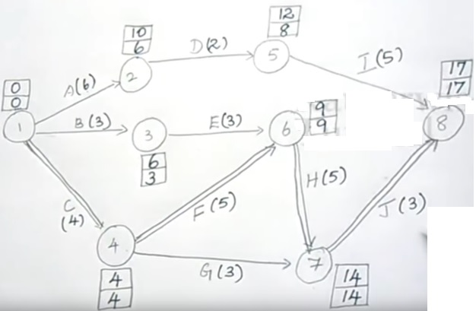

So,

Node 1- Node 4-Node 6-Node 7-Node 8

Expected project completion time= 4+5+5+3= 17 Weeks

d)

|  |  |  |  |  |  |
| --- | --- | --- | --- | --- | --- |
| Activity | Duration (weeks) | | | Mean / Expected  Duration | Variance |
| o | m | p |
| C | 1 | 4 | 7 | 4 | 1 |
| F | 1 | 5 | 9 | 5 | 1.777777778 |
| H | 4 | 4 | 10 | 5 | 1 |
| J | 2 | 2 | 8 | 3 | 1 |
| Total | | | | µ =17 weeks | 4.77777778 |

Therefore , σ =√4.78 = 2.19 weeks

P(x≤22) = P [ ((x-µ)/ σ) ≤ ((22-17)/2.19)]

= P [ z ≤ 2.28 ]

= 0.9887 (Using Z table, std. normal distribution table)

Therefore,

the probability of completing the project on or before 22 weeks is 0.9887 (98.87%)

### Q1. You invest 10,000 taka now, receive 5 yearly payments of 1,000 taka, 6,000 taka, 4,000 taka, 3,000 taka and 1,000 taka each. Find the internal rate of return (IRR) from the above scenario. Use an Interest Rate of 10% to work out the net present value (NPV) and profitability index (PI).

Solution:

IRR=16.1%

NPV= 997

PI= 1.10

### Q2. You start a construction company. You receive taka 500,000 upfront and taka 10M at the end of year 5. It will cost taka 4M/year for the next 4 years to complete the project. Your cost of capital is 10%. Find the IRR (-17.24% or 799.61%). Based on the value of IRR, will you like to accept or reject the project? Justify it.

Solution:

### The value of IRR is -17.24% or 799.61%.

Q3. Draw an arrow diagram to represent the following project. Calculate occurrence times of events, activity times, and activity floats (total float, free float, interference float and independent float). Also determine the critical path and the degree of criticality of other float paths.

|  |  |  |
| --- | --- | --- |
| Activity | Preceding Activity | Time (days) |
| A | None | 5 |
| B | A | 7 |
| C | A | 4 |
| D | A | 8 |
| E | B | 6 |
| F | D | 8 |
| G | E, C, F | 3 |
| H | G | 4 |
| I | G | 6 |

Solution:

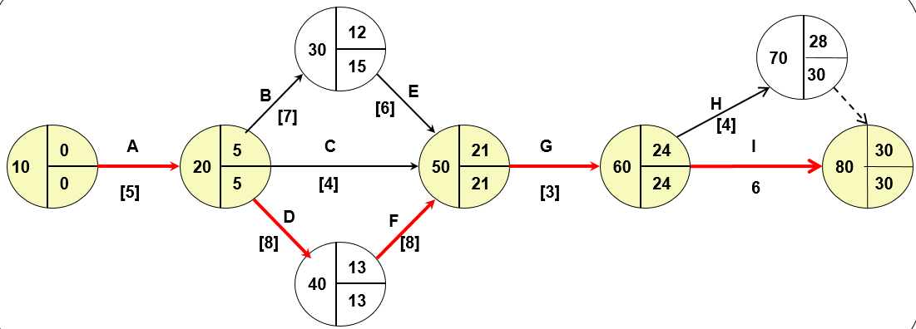

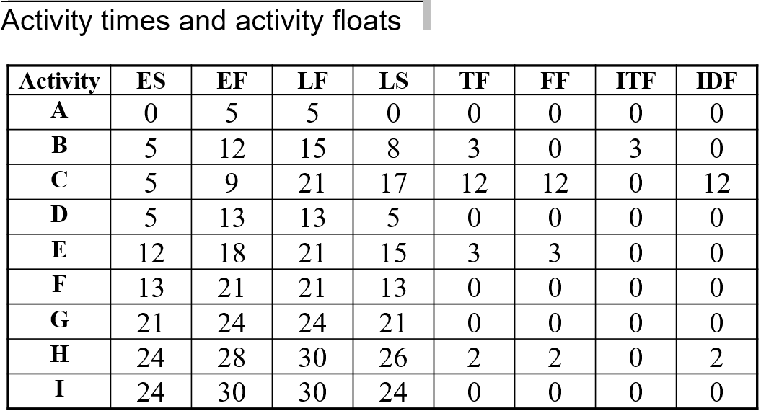

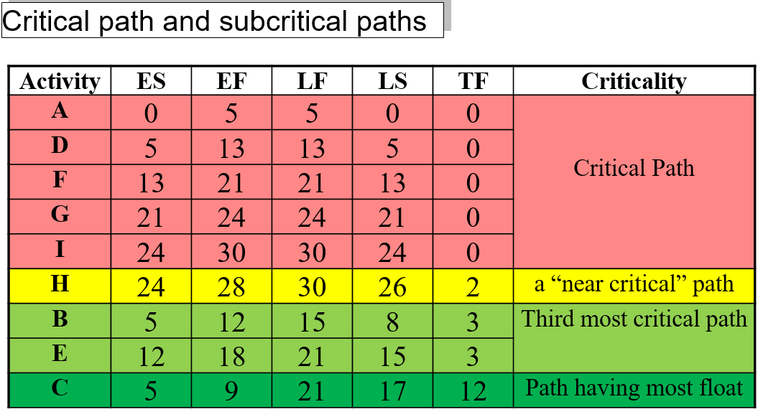

### Q4. You have to choose between two investments. The first investment requires to pay 19,89,453 taka three years from now, but it will earn you cash flow every year from the 2nd year to 6th year; starting with 1,29,827 taka on the second year; and this will grow 5% per year for 3 years; plus you will get back a lump sum of 16,39,837 taka on the 6th year.

### The second investment requires you to pay only 18,73,963 taka today, and then you will earn 4,23,296 taka beginning 1 year from now and this will continue until the 5th year. Government bond rate stands at 2.3%.

### You can afford either investment but can only choose one. With the NPV concept, which is a better investment for you, and by how much is it better?

Solution:

Investment Number2 is better by 7855.88

Q5. The following table gives data on normal time and cost and crash time & cost for a project

|  |  |  |  |  |
| --- | --- | --- | --- | --- |
| Activity | Normal | | Crash | |
| Time(weeks) | Cost (Taka) | Time(weeks) | Cost (Taka) |
| 1-2 | 3 | 300 | 2 | 400 |
| 2-3 | 3 | 30 | 3 | 30 |
| 2-4 | 7 | 420 | 5 | 580 |
| 2-5 | 9 | 720 | 7 | 810 |
| 3-5 | 5 | 250 | 4 | 300 |
| 4-5 | 0 | 0 | 0 | 0 |
| 5-6 | 6 | 320 | 4 | 410 |
| 6-7 | 4 | 400 | 3 | 470 |
| 6-8 | 13 | 780 | 10 | 900 |
| 7-8 | 10 | 1000 | 9 | 1200 |
| **Total cost = Taka 4220** | | | | |

The indirect cost per week is **Taka 50**.

a. Draw the network for the project & Critical path.

b. Find optimum time and optimum cost.

c. Determine minimum total time & corresponding cost.

Solution:

1. 1-2-5-6-7-8 = 32 weeks it is critical path (CPM) of the project duration.
2. optimum cost (Taka 5805) and optimum duration (29 weeks)
3. minimum total time (25 weeks) & corresponding cost (Taka 6150)

**BONUS**

Q6. The activities of a project along with their durations, predecessors and resource used are given in Table 1. If resource 1 is limited to 8 units and resource 2 is limited to one unit, determine the activities schedule start and finish times so that the weekly resource usage does not exceed the resource limits.

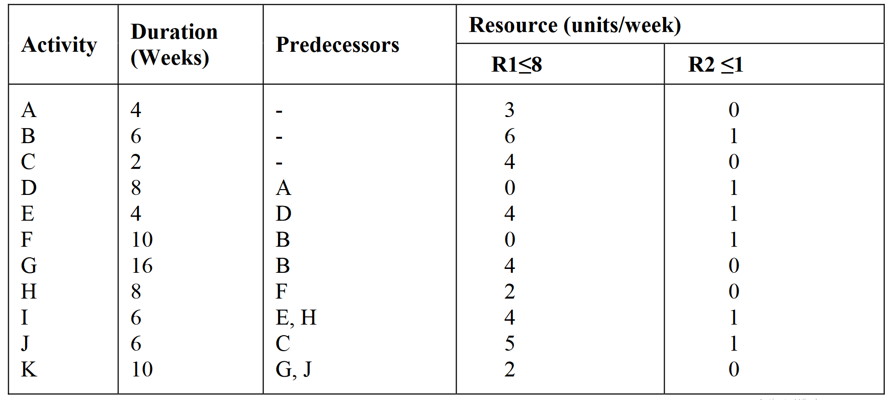

Table1

Answer:

The project network is drawn and the activities timings are calculated giving a project completion time of 32 weeks without considering the resource limits.

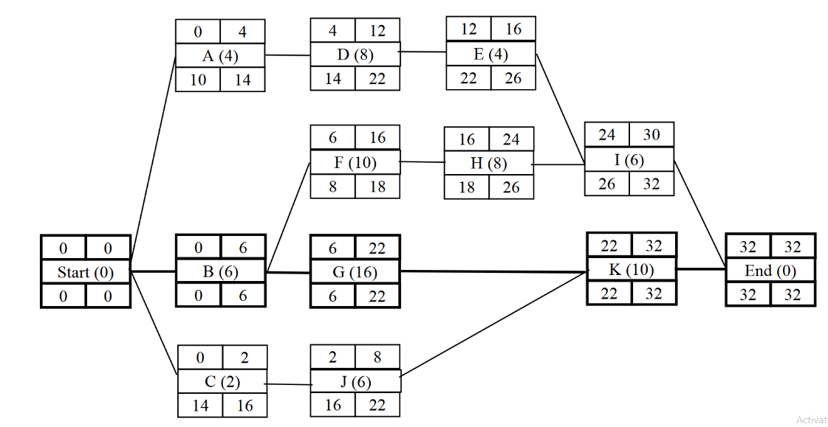

The solution will be arranged in the Table below

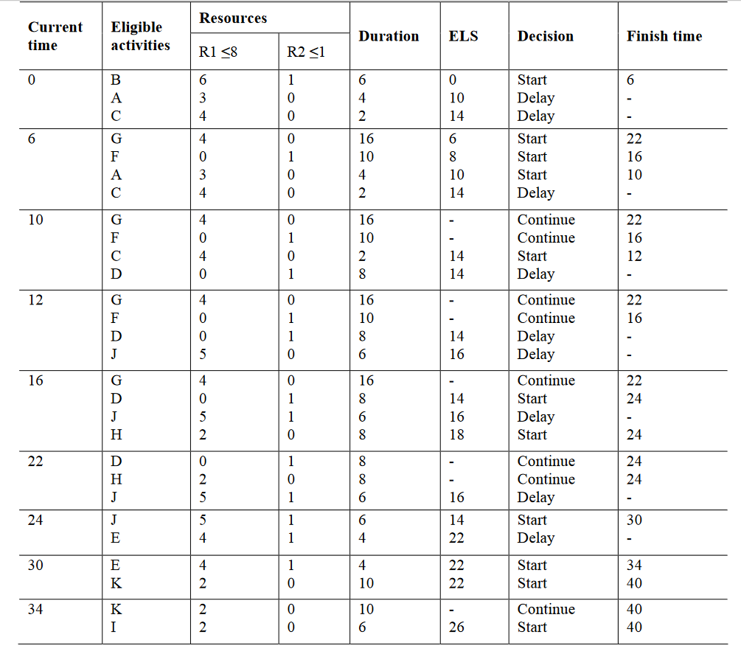

Then, the project completion time is 40 weeks with activities timing as given below:

